LAB 02
K25-0064
Sarim Raza Ansari
BAI-2A
Task1
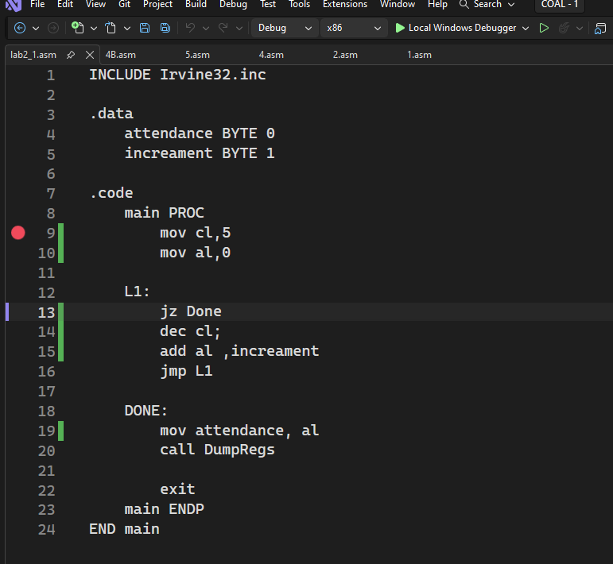
Error was on line 14, we have to interchange line 13 and 14
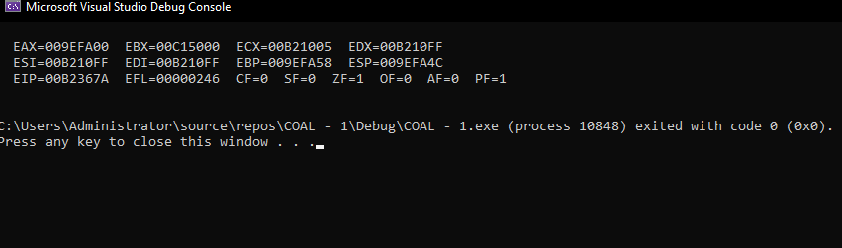

Task 02:
INCLUDE Irvine32.inc

COMMENT!
This data stores basic info
of stidents
!
.data

studentRollNo DWORD 250064 ;storing roll No
studentGrade BYTE 'A' ;storing Grade
semesterNo BYTE 9 ;storing semester

.code
main PROC
mov eax,0
mov ebx,0
mov ecx,0
mov eax,studentRollNo
mov bl, studentGrade
mov cl, semesterNo

call DumpRegs

exit
main ENDP
END main
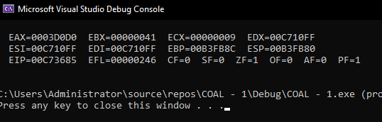
Task 03:
.data

itemCode BYTE 125 ; BYTE stores 0-255, suitable for item code
itemPrice WORD 25000 ; WORD stores a larger value than BYTE
dailySales DWORD 5000000 ; DWORD stores very large integer values
itemName BYTE "Milk", 0 ; Stores string followed by null character

Task 04
.data

COMMENT !
SBYTE is used because temperature change may be
positive, negative, or zero.
!

tempRise SBYTE +5 ; Temperature increased by 5 degrees
tempFall SBYTE -3 ; Temperature decreased by 3 degrees
tempNoChange SBYTE 0 ; No temperature change

Task 05:
INCLUDE Irvine32.inc

.data
bookIssuedToday DWORD 0
bookIncreament DWORD 1

.code
main PROC
mov ecx, 10
mov eax, 0

CountLoop:
cmp ecx,0
je Finished
add eax, bookIncreament
dec ecx
jmp CountLoop

Finished:
mov bookIssuedToday, eax
call DumpRegs
exit
main ENDP
END main

